**IMPORTING UPDATE SET IN SERVICENOW:**

Download both “OOB Button Fix” and “Custom Button Fix” XML

**Steps to Import OOB Button Fix update set in ServiceNow**

Download the Update set XML “OOB Button Fix”

Change the scope into Global

In the application navigator, **System Update Sets > Retrieved Update Sets**.

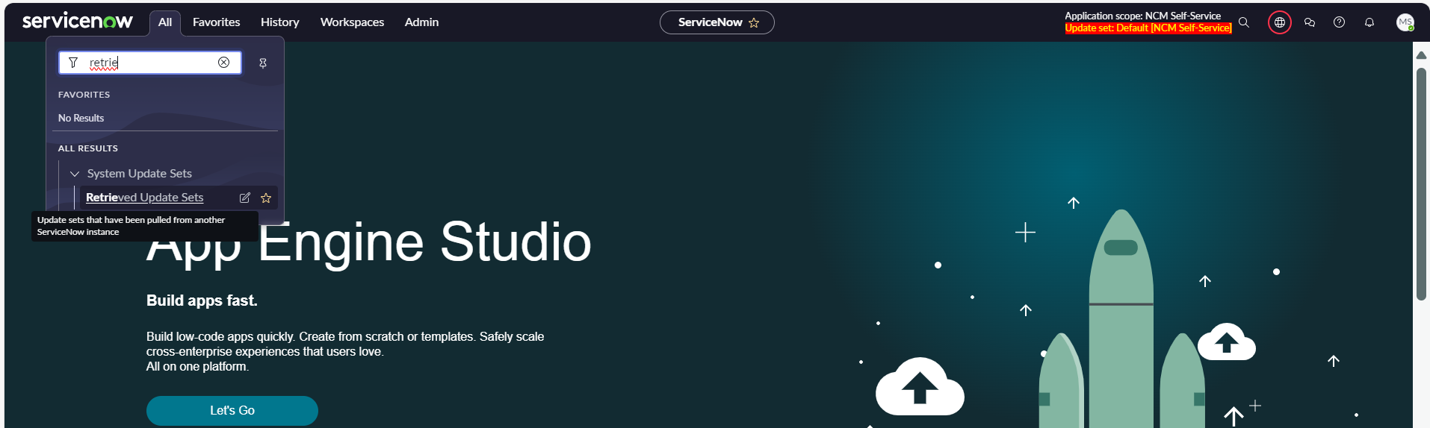

Click on the **Import Update Set from XML** button

Browse to select the XML file of the update set

After selecting the file, click on **Upload**.

Once uploaded, the update set will appear in the list. Click on the name of the update set to open it.

click on the **Preview Update Set** button

If you have fail message like the above picture, Scroll down to “Update Set Preview Problems” , With the record selected Choose **Accept Remote Update** otherwise just **click commit update set**

click **Commit Update Set** to apply the changes to your instance.

**Steps to Import Custom Button Fix update set in ServiceNow**

Download the Update set XML “Custom Button Fix”

Change the Scope into NCM Self Service

In the application navigator, **System Update Sets > Retrieved Update Sets**.

Click on the **Import Update Set from XML** button

Browse to select the XML file of the update set

After selecting the file, click on **Upload**.

Once uploaded, the update set will appear in the list. Click on the name of the update set to open it.

click on the **Preview Update Set** button

If you have fail message like the above picture, Scroll down to “Update Set Preview Problems” , With the record selected Choose **Accept Remote Update** otherwise just **click commit update set**

click **Commit Update Set** to apply the changes to your instance.

